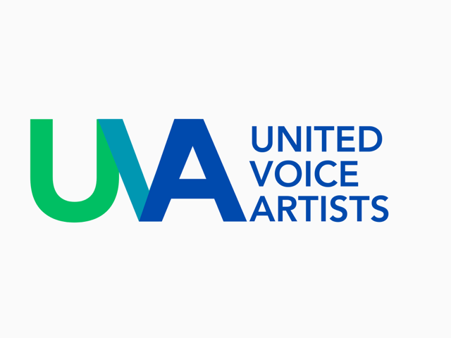

UVA, United Voice Artists is a worldwide group of voice acting guild associations and unions

World Voice Professionals Speaking Up

Ever since the ﬁrst drawing etched by hand on the wall of a cave, since the ﬁrst musical note, since the ﬁrst written document, human beings have always felt the need to express their own artistic intelligence. The act of creating is part of human nature and involves using one’s imagination and vision for the future and, in particular, through the human voice. The undiscriminating and unregulated use of Artiﬁcial Intelligence is a risk that could lead to the extinction of an artistic heritage of creativity and wonder, an asset that machines cannot generate.

In an effort to protect and preserve this heritage, professional Voice-Over Artists, members of leading EU guild associations and unions (France, Spain, Italy, Germany, Austria, Belgium, Poland) together with Switzerland, the United Kingdom, the United States of America, Turkey and Latin America, have joined forces to create UVA, United Voice Artists

UVA strives to collaborate with European decision makers to establish regulations that align the use of AI technologies with human creativity and the undivided respect of the General Data Protection Regulation (GDPR) and artists' rights. Consequently, political initiatives are crucial to safeguard the livelihood of Voice-Over Artists, which depends on fair treatment of their work and their contributions to the preservation of the authentic cultural identity of their communities.
UVA calls on EU politicians and legislators to address:

- the inherent risks, both legal and ethical, in the conception, training and marketing of AI generated content.
- the need to adjust the protection of artists' rights and GDPR
rules, with the development of AI technologies in Europe.

Our concerns:

Protecting actors’ work and human creativity: Any use of AI technology to generate and clone human voices must be subject to the explicit consent of the Voice-Over Artists and Performers, which must therefore be in a position to refuse the use of their works and performances, past and future, for purposes not expressly authorised by them, and be offered practical solutions to ensure the effectiveness of this choice.

Preserve Property Rights and Intellectual Property Rights: Currently, generative AI technology heavily depends on online sourcing to enhance its learning capabilities, which regularly involves the illicit scraping and use of copyrighted data and content. The collection process does not bother itself with verifying whether or not this data and content can be reused.

Protecting personal data: VO Artists alert data protection authorities that Generative AI technologies are likely to feed off “sensitive” personal data (voice is considered biometric data under the GDPR), in contexts and for purposes that are not yet well defined nor transparent.

Harmonise image rights, personality and publicity rights across the EU bloc:
Currently there is a patchwork of national laws within the EU leaving artists uncertain about their protection over their face, their voice and their likeness in commercial applications.

Liability for generated content: the AI Act must ensure that the primary
responsibility and liability for any harm caused lies with the source of the generative AI systems, the providers of the foundation models, as well as any provider of a downstream application.

Ensuring transparency for generative AI: Every cloned and/or synthetic voice must be clearly labeled and traceable with a speciﬁc and audible tag, so that users are aware of the nature of the speaking voice. This request is in line with the provision of identifiability of content generated by AI systems, in the draft EU AI Act, but must be further enhanced.

Sustainability of a cultural asset: Voice talents are part of the cultural assets of their communities. The role they play in the conservation of the collective identity must therefore be protected.

Implementing a moratorium: A moratorium on the use of voice synthesisation and cloning techniques with generative AI must be put in place until there is clear regulation protecting the rights of all voice professionals, securing the continuity of their cultural role.

Establish dialogue: An open and constructive dialogue must be established between studios, Voice-Over Artists and all other participants in the industry to guarantee that the rights of voice professionals are honored. This also includes the mandatory introduction of contractual terms to prevent the use of human voice samples with generative AI technologies for training purposes, without the active consent of the performers/owners.

UVA, United Voice Artists is a global coalition of voice acting guild associations and unions that have united to pursue their shared goals.
This collaborative effort brings together prominent associations and unions from the European Union, including France, Spain, Italy, Germany, Austria, Belgium, and Poland, as well as organizations in Switzerland, the United Kingdom, Turkey, the United States of America and in South America.

